# **Stats Library Documentation**

# **Overview**

This library contains tools for statistical analysis, probability calculations, and discrete mathematics. It provides functionality ranging from basic statistical measures (mean, median, variance) to more complex operations (conditional probability, binomial distributions, permutations and combinations).

The architecture follows a handler-based pattern where specialized handler classes manage different calculation types while delegating the actual computation to dedicated calculator classes. This separation of concerns creates a maintainable and extensible codebase. (see technical details section for more)

Output formatting utilizes ANSI color codes to produce visually distinct results that clearly differentiate between operations, inputs, and outputs, enhancing readability when viewing calculation results.

## **Core Components**

### **Basic Statistics**

* **Mean**: Calculates arithmetic mean of datasets
* **Median**: Determines middle value in ordered datasets
* **Mode**: Identifies most frequent value(s) in datasets
* **Variance**: Measures dispersion from the mean
* **Standard Deviation**: Square root of variance

### **Set Operations**

* **Union**: Combines elements from two datasets
* **Complement:** returns the complement of a set
* **Intersection**: Identifies common elements between datasets

### **Probability Calculations**

* **Conditional Probability**: Calculates P(A|B)
* **Independence Testing**: Determines if events are independent
* **Law of Total Probability**: Calculates probability using conditional probabilities
* **Bayes' Theorem**: Calculates posterior probabilities

### **Probability Distributions**

* **Binomial Distribution**: For scenarios with fixed trials and success probability
* **Geometric Distribution**: For first success in sequence of trials

### **Discrete Mathematics**

* **Factorial**: Computes n!
* **Permutation**: Calculates nPr
* **Combination**: Calculates nCr

## **Usage Instructions**

The library can be used via command-line interface with specific operation keywords followed by appropriate arguments. For example:

* **java Main mean file1.csv file2.csv**

For a complete list of available operations, use:

* **java Main --help**

## **Technical Details**

### **Error Handling**

All calculation methods implement appropriate validation with descriptive exception messages for invalid inputs.

### **Number Precision**

Large number operations (factorial, permutations, combinations) utilize BigInteger for arbitrary precision.

### **Data Input/Output**

The library supports CSV file handling for data input and provides formatted console output with color-coding. This supports 1 OR 2 CSV’s.

## **Demo Functionality**

The OneForAll operation demonstrates all available functionality using sample data:

* **java Main OneForAll**

This command executes all operations with predefined parameters, showcasing the library's capabilities.

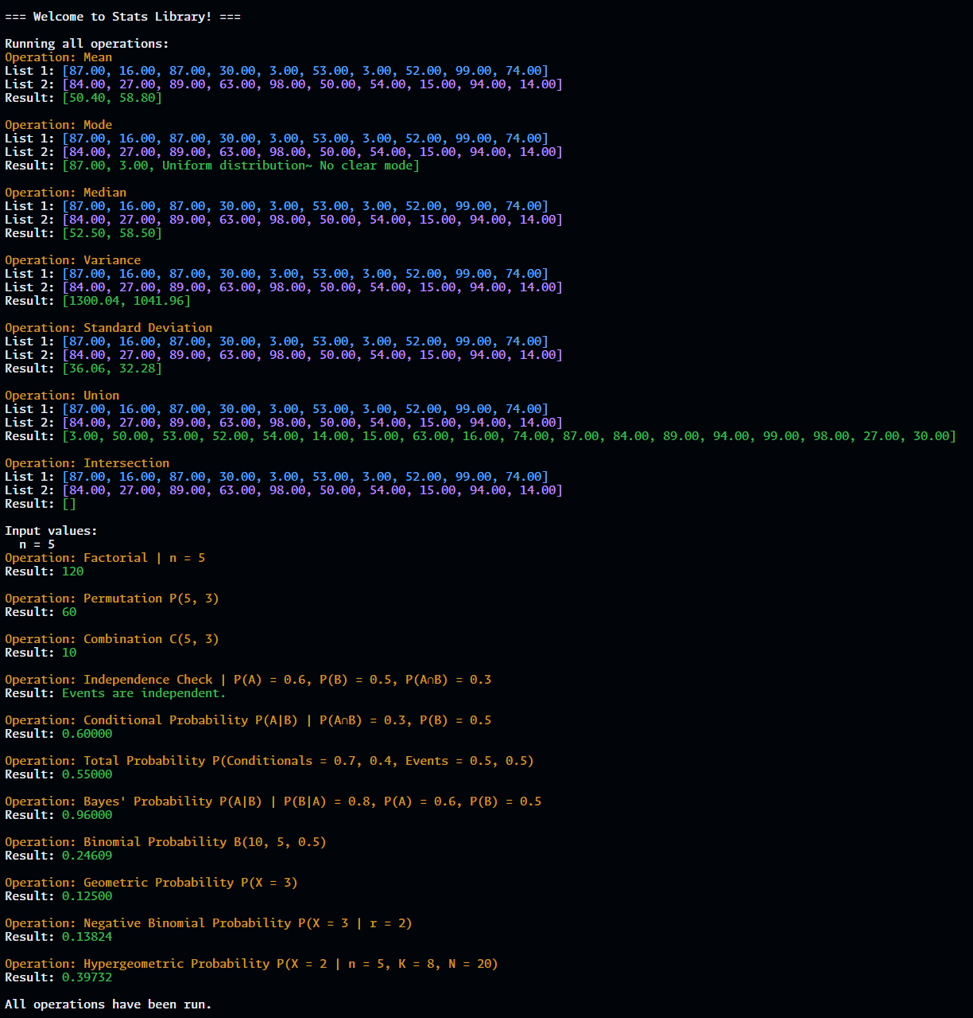

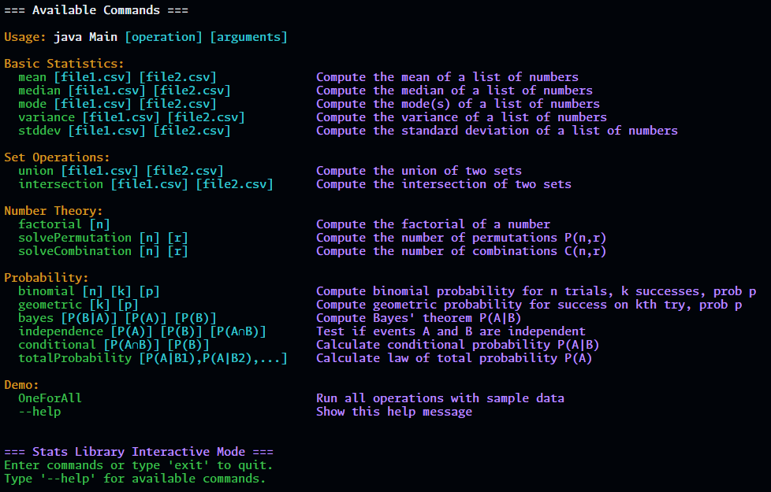

THIS IS ALL IN TERMINAL  
